CHEKCERS.IO

Project Plan
by

GROUP 3

Table Of Contents

Introduction ……………………………………………………………………………………………………………………….3
Project Organization..........................................………………………………………………………….…….…3
Risk Analysis.………………….………………………………………………………………………………..………………….4
Hardware/Software Requirements.…………………….………………………………….………….……………….5
Work Breakdown Schedule…..…………………………………………………………………………………….……….7
Project Schedule………………………………………………………………………………………………….….……………9
Monitoring/Reporting Mechanisms…………………………………………………………….…………..………....10
Appendices…………………………………………………………………………………………………………………..……..11

Introduction (Done)
This Project Plan provides the general framework and establishes specific strategies and milestones for execution of the Checker.io project. The Project Plan will define the project's requirements, expectations and schedule. This is a living document and will be updated as required on a regular basis until completion of the project.

Objective: Create a terminal based version of checkers using ASCII art that can be played on even the most minimalist of hardware configurations. Complete with the ability to play against either another person sharing the same machine, or against an AI opponent. Once the main loop is complete the user(s) will be able to review the game most recently played turn-by-turn.

Constraints: The system will not have a rules tutorial based on time constraints, though implementation of this could be done should work go more quickly than anticipated. It will also not be able to review games other than the one most recently played due to only using one file version being written to for recordkeeping purposes.

Project Organization (This needs filled in, with respect to group allocations. Of tasks)

Title | Name | Responsibility | Stakeholder Authorization
Group Leader | Emily Eshcoff | General Organization and Task Allocation | Authorized
Group Member | Benjamin Archer |  | Authorized
Group Member | Zachary Fike |  | Authorized
Group Member | Jayden Brooks |  | Authorized
Group Member | Carly Grubbs |  | Authorized
Instructor | Fatima Jackson | Final Review and Evaluation | Authorized

Risk Analysis(Done)

Risk | Description | Risk Level | Analysis
Incompletion of all methods | Not all required functions (move validation, capture logic, king promotion, win detection, board display) may be fully implemented within the short timeline. Missing methods will cause major portions of the game to break. | High | The team must prioritize core gameplay features first, implement methods in small testable pieces, and avoid starting optional features before required mechanics are complete. Daily progress checks are essential.
Methods don’t write or read from files | Save/load features, logs, or debugging file operations may fail due to incorrect file handling or path errors. This can prevent saving game state or reading configuration data. | Medium | Ensure file operations use correct paths and permissions. Test writing and reading early, use simple text formatting, and validate file existence before reading. Implement error-checking around file streams.
Game Loop doesn’t Loop properly | The main loop may prematurely exit, loop infinitely, or fail to alternate turns correctly. This will prevent the game from progressing or responding to inputs. | High | Break the loop into clear stages: input → validation → update → render → turn switch. Test the loop with mock moves before adding full logic. Add safe exit conditions to prevent infinite loops.
Players don’t know rules of the game or how to input moves into the game | Without clear instructions, players may enter invalid commands, misunderstand move formatting, or be unaware of legal Checkers rules. This leads to user errors and confusion. | Medium | Provide clear on-screen instructions, examples of valid inputs, and error messages. The user manual should include move examples and explanations of rules. Add input validation to guide players.
Game board matrix misalignment | The 8×8 board array may display incorrectly, causing visual errors such as shifted rows/columns or mismatched coordinates. This makes gameplay confusing or unplayable. | Medium | Test board rendering early. Print row/column labels, ensure loop indices match the visual grid, and validate that display formatting remains consistent after each move.

Hardware/Software Requirements (Done)

Specification A | Processor | - Any processor capable of running a terminal
Specification B | RAM | - 32 MB
Specification C | Storage | - 1 MB
Specification D | Network Adapter | - N/A
Specification E | Operating System | - Windows, Linux, macOS
Specification F | Programming Language | - C++
Specification G | Compiler | - MSVC, GCC, Clang
Specification H | Terminal Application | - cmd, PowerShell, bash

Work Breakdown Schedule First image is from excel, needs further details filled, Example images also left in for reference. Will use due dates on the Class Canvas or Syllabus to fill in date related details. Can also use final submissions requirements for task definitions.

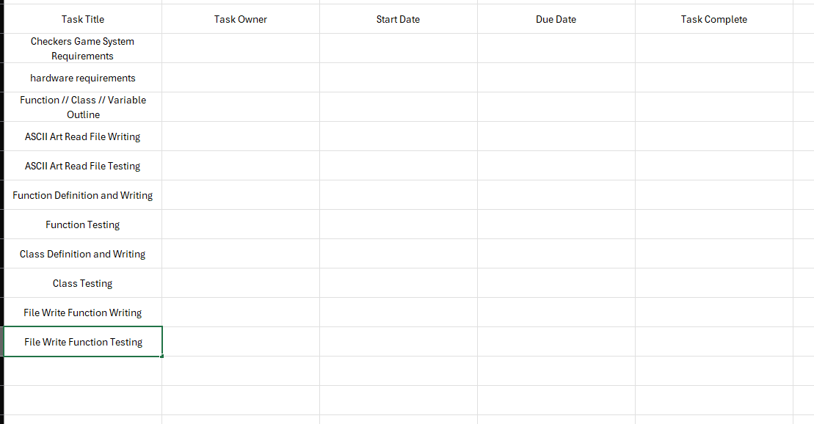

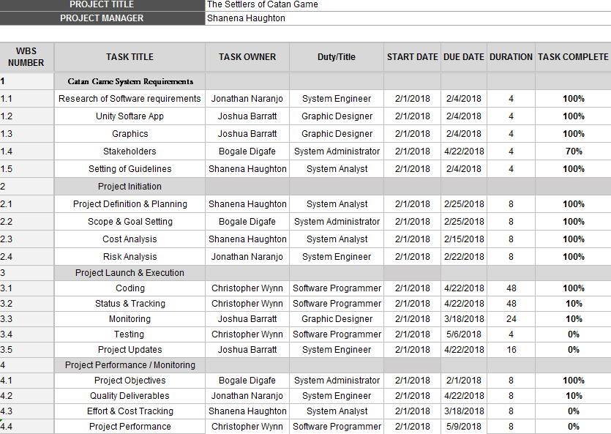

Work Breakdown Schedule (continued)
We probably don’t need this level of detail, but if anyone wants to make something like this it cant hurt. Would be nice to include past tasks already completed just for due diligence. Ie, repo creation and configuration, discord server creation and config, ect.

Project Schedule
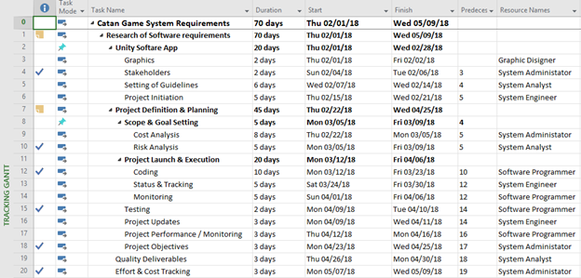
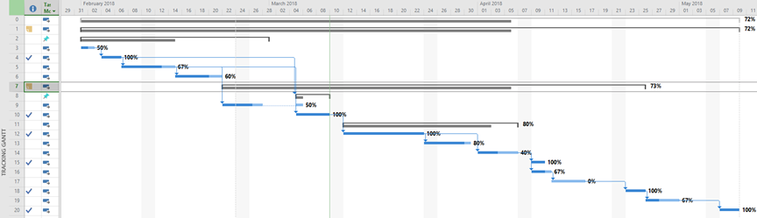

Monitoring and Reporting Mechanisms
Not sure how to change this for us. But we could figure something out.

Monitoring | Frequency
Meetings | Weekly
Deliverables | Determined by Project Schedule
Scrum | Daily via Slack

Reporting | Frequency
Activity Reports | Bi-monthly
WBS | As detailed in schedule

Appendix

We just need to replace these fields with respect to our project and this specific plan proposal.

Number of Activity | Description | Time Estimate | Dependencies
1 | Project Organization | 1 week | None
2 | Risk Analysis | 4 weeks | None
3 | Hardware/Software Requirements | 2 weeks | None
4 | Work Breakdown Schedule | 6 weeks | Project Organization; Project Scheduling
5 | Project Schedule | 15 weeks | Project Organization; Hardware/Software Requirements; Work Breakdown Schedule
5 | Monitoring/Reporting Mechanisms | 15 weeks | Project Organization; Hardware/Software Requirements; Work Breakdown Schedule; Project Schedule

